ELL Strategies

Table of Contents
Overview of Second Language Acquisition 3
Top 10 Strategies to Use All Day, Every Day 4
Total Physical Response 5
Cooperative Learning 6
Language Experience Approach 7
Dialogue Journal 8
Accessing Prior Knowledge 10
Vocabulary Web 13
Note-taking/Summarizing 14
Explicit Vocabulary Instruction 15
Inquiry in the Content Areas 16
Pre-Reading 18
Think-Alouds 20

Overview of Second Language Acquisition
(Adapted from Strategies and Resources for Mainstream Teachers of English Language Learners, (2003), NWREL
One concept endorsed by most current theorists is that of a continuum of learning—that is, predictable and sequential stages of language development, in which the learner progresses from no knowledge of the new language to a level of competency closely resembling that of a native speaker. These theories have resulted in the identification of several distinct stages of second language development. These stages are most often identified as:
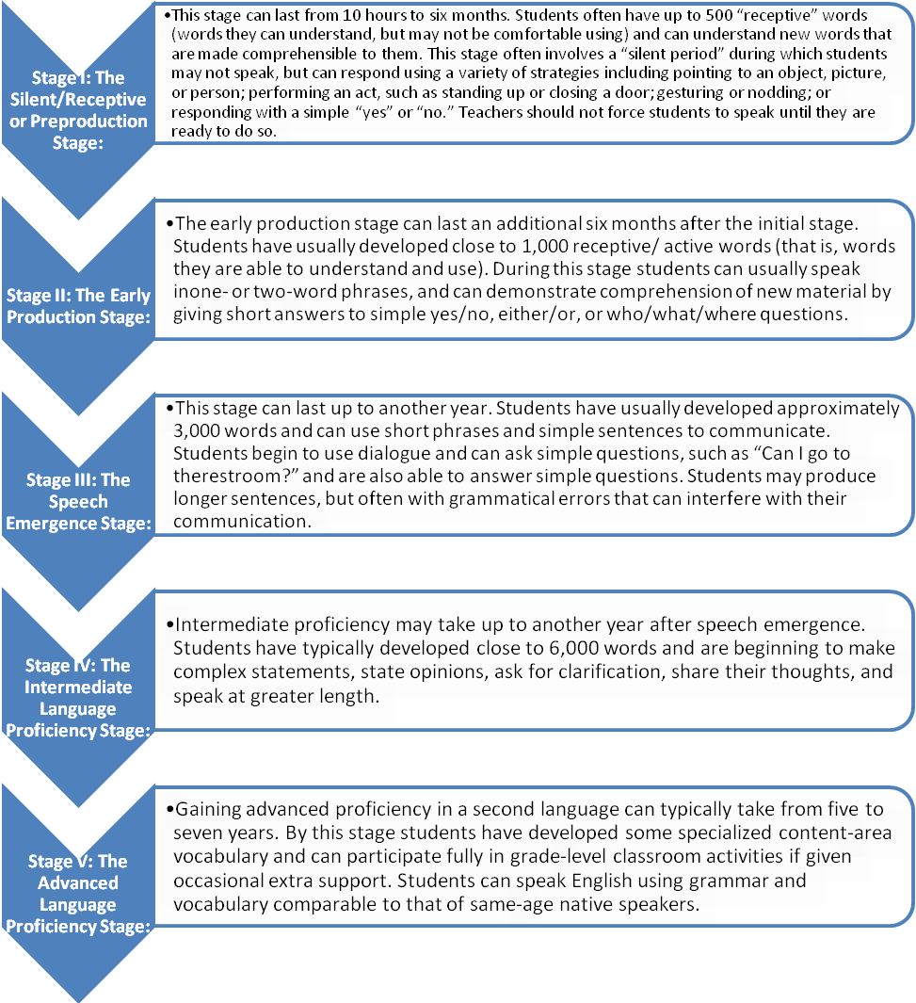

Top 10 ELL Strategies to Use All Day, Every Day
(Adapted from Strategies and Resources for Mainstream Teachers of English Language Learners, (2003) NWREL

- Enunciate clearly, but do not raise your voice. Add gestures, point directly to objects, or draw pictures when appropriate.

- Write clearly, legibly, and in print—many ELL students have difficulty reading cursive.

- Develop and maintain routines. Use clear and consistent signals for classroom instructions.

- Repeat information and review frequently. If a student does not understand, try rephrasing or paraphrasing in shorter sentences and simpler syntax. Check often for understanding, but do not ask “Do you understand?” Instead, have students demonstrate their learning in order to show comprehension.

- Try to avoid idioms and slang words.

- Present new information in the context of known information.

- Announce the lesson’s objectives and activities, and list instructions step-by-step.

- Present information in a variety of ways.

- Provide frequent summations of the salient points of a lesson, and always emphasize key vocabulary words.

10. Recognize student success overtly and frequently. But, also be aware that in some cultures overt, individual praise is considered inappropriate and can therefore be embarrassing or confusing to the student.

Total Physical Response (TPR)

(Adapted from Fifty Strategies for Teaching English Language Learners, (2000) Herrell, Adrienne)

Purpose:
TPR emphasizes the use of physical activity to increase meaningful learning opportunities and language retention. Students become ready to talk sooner when they are learning by doing. TPR activities help students adjust to school and understand the behaviors required and the instructions they will hear. This will help them in mainstream classrooms, in the halls, during lunchtime, during fire drills, on field trips, and in everyday life activities.

Applications:
Classroom routines, read-aloud, content vocabulary instruction (movement directions, students’ names, color words, shapes, body parts, prepositional phrases, directions)

General Description of Strategy:
TPR is a language-learning tool based on the relationship between language and its physical representation or execution. A TPR lesson involves a detailed series of consecutive actions accompanied by a series of commands or instructions given by the teacher. Students respond by listening and performing the appropriate actions (Asher, 2000a).

Examples:

- Choose vocabulary that will be used in the classroom such as verbal directions, colors, and parts of the body. List the words students need to know. Think of simple commands that can be given using the target vocabulary and that require a movement response such as “stand up”, “show me the red block”, etc.
- Introduce two or three commands at first, giving the command while demonstrating physically. Motion for the students to do it with you. After you have demonstrated all three commands, randomly alternate them.
- After the students have practiced the commands as you demonstrate each time, and they appear to know what to do without waiting for your demonstrations, drop the demonstration and have them respond to your verbal commands only.
- Add new commands (no more than three at a time). Repeat steps 1-3.
- Find new ways for the students to demonstrate their understanding of the vocabulary being practiced.
- Play a game with a student volunteer giving the commands once the students gain confidence.

Cooperative Learning

(Adapted from Fifty Strategies for Teaching English Language Learners, (2000) Herrell, Adrienne)

Purpose:
Through a shared learning activity, students benefit from observing learning strategies used by their peers, learning and practicing language in context, and having increased verbal interactions

Applications:
Calderon suggests that “cooperative learning is effective when students have an interesting well-structured task such as a set of discussion questions around a story they just read, producing a cognitive map of the story, or inventing a puppet show to highlight character traits” (2001, p. 280).

General Description of Strategy:
Robert E. Slavin (1995) has shown cooperative learning can be effective for students at all academic levels and learning styles. Cooperative learning involves student participation in small-group learning activities that promote positive interactions.

Examples:
- Round Robin - Present a category (such as "Names of Mammals") for discussion. Have students take turns going around the group and naming items that fit the category.
- Roundtable - Present a category (such as words that begin with "b"). Have students take turns writing one word at a time.
- Write-around - For creative writing or summarization, give a sentence starter (for example: If you give an elephant a cookie, he's going to ask for...). Ask all students in each team to finish that sentence. Then, they pass their paper to the right, read the one they received, and add a sentence to that one. After a few rounds, four great stories or summaries emerge. Give children time to add a conclusion and/or edit their favorite one to share with the class.
- Numbered Heads Together - Ask students to number off in their teams from one to four. Announce a question and a time limit. Students put their heads together to come up with an answer. Call a number and ask all students with that number to stand and answer the question. Recognize correct responses and elaborate through rich discussions.
- Team Jigsaw - Assign each student in a team one fourth of a page to read from any text (for example, a social studies text), or one fourth of a topic to investigate or memorize. Each student completes his or her assignment and then teaches the others or helps to put together a team product by contributing a piece of the puzzle.
- Tea Party - Students form two concentric circles or two lines facing each other. You ask a question (on any content) and students discuss the answer with the student facing them. After one minute, the outside circle or one line moves to the right so that students have new partners. Then pose a second question for them to discuss. Continue with five or more questions. For a little variation, students can write questions on cards to review for a test through this "Tea Party" method.

Language Experience Approach

(Adapted from Fifty Strategies for Teaching English Language Learners, (2000) Herrell, Adrienne)

Purpose:
Students learn how their language is encoded as they watch it written down, building sight word knowledge and fluency as they use their own familiar language. This approach allows students to bring their personal experiences into the classroom with reduced anxiety. (Peterson, Caverly, Nicholson, O’Neal, & Cusenbary, 2000).

Applications:
Modeled writing, small group or one-on-one guided writing, parent newsletters, classroom posters and books

General Description of Strategy:
This approach uses students’ words to create a text that becomes material for a reading lesson (Carrasquillo & Rodriguez, 2002). Students describe orally a personal experience to a teacher or peer. The teacher or another student writes down the story, using the student’s words verbatim. The teacher/student then reads the story back as it was written, while the student follows along. Then the student reads the story aloud or silently. Other follow-up activities can be done with this approach.

Examples:
- Provide an active learning experience or have the student(s) share an experience.
- Engage the student(s) in conversation about the activity they have experienced. Encourage them to use full sentences.
- Record the students’ descriptions of their experience:
  - Repeat the sentence to be written and then say it again one word at a time as you write it.
  - Have the students read the sentence along with you, pointing to each word as it’s read.
  - If sequence is important to the text, ask leading questions such as, “And then what did we do?”
  - If the students are not dictating the sentences in proper sequence, you may want to record their sentences on sentence strips so that they can be rearranged in sequence after all sentences have been written.
- When the entire text has been dictated, reread it aloud with the student(s) reading along.
- Provide time and materials for the student(s) to decide how to publish the text.

Dialogue Journals

(Adapted from The National Clearinghouse of English Language Acquisition: http://www.ncela.gwu.edu/practice/itc/)

Purpose:
This approach is a way for teachers to engage students in writing.

Applications:
Do Now, choice writing, exit slips

General Description of Strategy:
Students write in a journal, and the teacher writes back regularly, responding to questions, asking questions, making comments, or introducing new topics. Here the teacher does not evaluate what is written, but models correct language and provides a nonthreatening opportunity for ELL students to communicate in writing with someone proficient in English, and to receive some feedback (Peyton, 2000; Reid, 1997). Reid’s literature review and her action research project show dialogue journaling with a teacher to be beneficial in improving spelling and fluency.

Examples:
Grade: 2-6
Content Area:Language Arts
Objective:
The student will be able to:

1. Communicate in writing with the teacher on a variety of topics.

2. Express and explain points of view and opinions on events.
Materials:
Composition books (or nice, cloth bound journals if students prefer).
Introduction and Implementation:
When introducing this activity to students, keep in mind that not all students will use this tool effectively if they are left to their own devices. Making it a requirement that you and the student must exchange journals once a week is a reasonable amount of time. Students should be able to exchange the journal with you more frequently than that is they desire, but no less than once a week.
Begin the journal with an easily understood/answered question, such as "tell me about your favorite day at school." You might begin by briefly telling your students what your experiences are, what your feelings are, and allow the student to either comment on your writing or to write his or her thoughts.
Upper elementary students should be challenged to write about topics on current events. This can be a very effective tool to build self-esteem and life skills. Lower elementary students might stick to more concrete subjects, such as "what is the best thing you did in school this week?"
These journals should be considered separate from writing journals, or used in conjunction wtih them. However, the major difference between writing journals and dialogue journals is that the teacher responds with his or her own experiences, ideas, and thoughts. Brief comments such as "interesting!" should be limited to writing journals, while more expansive responses are necessary for dialogue journals.
Assessment:
Discuss the students progress throughout the journal with the student. Refer back to old entries, remark on the change of sentence structure or spelling. Note if certain mistakes are consistently made and address those either in a lesson or in the journal. This can be an excellent assessment tool in addition to a bonding activity with your students.

Accessing Prior Knowledge

(Adapted from The National Clearinghouse of English Language Acquisition: http://www.ncela.gwu.edu/practice/itc/)

Purpose:

Creating a visual, such as “semantic webs,” with the topic in the center and students’ knowledge surrounding it, is a good way to engage students in the topic and to find out what they already know. Another simple technique is to ask them what they want to learn about a topic. As Savaria-Shore and Garcia (1995) note: “Students are more likely to be interested in researching a topic when they begin with their own real questions” (p. 55).

Applications:
All subjects

General Description of Strategy:
Using a student’s native language can be an important way to access his or her previous knowledge (Marzano, Gaddy, & Dean, 2000). All students, regardless of their proficiency in English, come to school with a valuable background of experience and knowledge on which teachers can capitalize. One example when teaching a new concept, is to ask students what they already know about a subject.

Examples:
Grade: 6-12
Content Area: Social studies
Source: Excerpt from Success in Educating All Students (NCBE, 1996); A. Vincent,
1. Read aloud an excerpt from Childtimes, by children's author, Eloise Greenfield.
People...are affected...by big things and small things. A war, an invention such as radio or television, a birthday party, a kiss. All of these experiences help to shape people, and they in turn, help to shape the present and the future... (Greenfield and Little, 1979)
Share stories of how events in history have dramatically impacted your own life. A teacher in Washington, DC, shared the following examples with her English as a second language (ESL) class: (a) during the 1968 racial riots in Detroit, she and her family were among the few non-African Americans that she knew that stayed. Her old friends moved to the suburbs while she made new friends and learned among a community from which she had been previously isolated; (b) the invention of word processors has opened up a world of writing that she would never have pursued by hand; (c) the economic crisis in Latin America forced her husband to leave Colombia. Because of this, she met him in Washington, DC, got married, and had a child.
Have students think of ways in which historic events or developments have impacted their lives. After a few have shared their stories, ask the whole class to write (draft without concern for spelling or grammar at this point) on the topic. In the class mentioned above, one student wrote about how her family had to stay in the house for weeks during the US invasion of Panama; a number of students from Ethiopia wrote about how the war affected their lives, and one wrote about how her role as a woman has shifted now that she lives in the new cultural environment of the United States.
2. Timelines: By creating personal timelines, students can see how their own lives and the lives of their classmates are tied to history.
Begin by having students phrase in their own words the quote, "An unexamined life is not worth living." Explain that the class will study the history of the community and country that we live in- beginning with the lives of the students in the class.
The teacher should prepare in advance a timeline of her own life to share with the students. Highlight dates that you know will trigger ideas for students, (e.g., when you met your best friend, first day of school, first day at work, times you have traveled, the gain or loss (birth or death) of a family member, when you learned a second language, and so on).
Have students begin to develop their own timelines. Students can expand the timelines by interviewing family members to collect dates that go back a couple of generations. When did parents or grandparents get married, come to the United States, or other highlights in their lives? Again, model first with your own timeline so that students can get ideas about the kind of information they might solicit from their relatives.
Combine the student and teacher timelines into a collective class timeline. This can be illustrated with drawings or bar graphs. Add key historical events to the personal or collective timelines so that students can see the relationship between their lives and history.
3. Questions for History
Discuss the following statement by noted historian, Howard Zinn,
"I started studying history with one view in mind: to look for answers to the issues and problems I saw in the world about me. By the time I went to college I had worked in a shipyard, had been in the Air Force, had been in a war. I came to history asking questions about war and peace, about wealth and poverty, about racial division.
Sure, there's a certain interest in inspecting the past and it can be fun, sort of like a detective story. I can make an argument for knowledge for its own sake as something that can add to your life. But while that's good, it is small in relation to the very large objective of trying to understand and do something about the issues that face us in the world today." (Zinn, 1991)
Teachers can share some questions about history that they have based on their own life experiences. For example, a teacher shared how she and her husband both work, but when they go home in the evening it is expected that she should take care of the baby. So her question for history is: Why do women have to do more work than men?
Ask students to look at their own lives--what problems do you have? Ask history--where does this problem come from? Be prepared for some pretty profound questions. Use these to shape your teaching of history. For example, the following are a few of the questions asked in a class with students from Ethiopia, El Salvador, the Philippines, and Vietnam:
- Why is there so much discrimination?
- Why do we have fights between different countries and why do we fight our own people?
- Why do women still get raped? (a boy asked this question)
- Why are so many people poor? Why do some people have more money than others?
- Why do people make so many bad comments about Africa? So many people tell me--if you come from Africa--did you live like an animal in the jungle?
- Why did racism start? When did it start? (We found this to be a burning question and concern for ESL students. Studies of the 1600s and 1700s when racism was institutionalized (Zinn, 1981; Bennet, 1992) help to address a lot of the students' questions.)
This personal connection should be made not just at the beginning but also throughout your study of history. This helps students to understand the themes and concepts in terms of their own experiences. Students also learn about each other's strengths and cultures.

Vocabulary Webs

(Adapted from The National Clearinghouse of English Language Acquisition: http://www.ncela.gwu.edu/practice/itc/)

Purpose:

Providing content area vocabulary gives students the ability to communicate in mainstream classes and to understand content-area-specific terminology. Vocabulary may be initially taught directly or in context. To reinforce vocabulary, teachers should create contexts in which students work with and use content-specific vocabulary regularly in their reading, writing and speaking. Effective vocabulary instruction should accomplish the following: 1) increase reading comprehension; 2) develop knowledge of new concepts; 3) improve range and specificity in writing; 4) help students communicate more effectively; and, 5) develop deeper understanding of words and concepts

Applications:
Introducing new vocabulary and concepts in literature and content areas

General Description of Strategy:
It is a graphic organizer used to internalize word meanings. Opportunities for identifying the key word in several contexts are provided.

Examples:

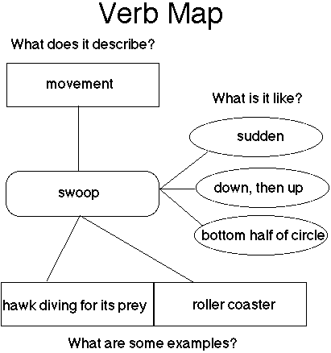

Note-taking/Summarizing

(Adapted from The National Clearinghouse of English Language Acquisition: http://www.ncela.gwu.edu/practice/itc/)

Purpose:
English language learners in particular, who are extracting new information through a new language, may require explicit instruction in these techniques.

Applications:
Literature and all content areas

General Description of Strategy:
The strategies of note taking and summarizing involve extracting the information that is important to remember from a book or other literature, a lecture or other event. One way teachers can show students how to summarize is by using a series of questions that frame the critical information: Where does the story take place? Who are the main characters and what are they like? Tools for effective note taking include outlining essential points and webbing their relative importance.

Examples:
Grade: 2
Content Area: Language Arts
Source: Marzano, Pickering & Pollock. (2001). Classroom Instruction That Works: Research-Based Strategies for Increasing Student Achievement.
The following activity shows one second-grade teacher's use of the conversation frame to teach students summarizing skills. Although the lesson was not developed specifically for English language learners, it reflects appropriate instructional strategies for this group.
Read The Billy Goats Gruff aloud once or twice. Work with the class to answer these or similar "framing" questions. (Sample responses are shown here to illustrate.)
1. How did the members of the conversation greet each other?
The mean troll grunted at Little Billy Goat gruff. The little goat just gave his name.
2. What questions or topics was revealed, insinuated, revealed or referred to?
The topic of the conversation was about whether the goat could cross the bridge.
3. How did the conversation progress?
The troll threatened to eat the goat if the goat crossed his bridge.
4. What was the conclusion?
The goat talked the troll into waiting for his bigger brother.
With the class, combine the responses to write a complete summary.

Explicit Vocabulary Instruction

(Adapted from http://www.colorincolorado.org/

Purpose:
Developing vocabulary is essential for reading comprehension. Readers cannot make meaning of what they are reading without knowing what most of the words mean. Children must learn the meanings of new words that are not necessarily part of their oral vocabulary.However, to know a word means knowing it in all of the following dimensions:
- The ability to define a word
- The ability to recognize when to use that word
- Knowledge of its multiple meanings
- The ability to decode and spell that word
Therefore, it is vitally important to teach key words that children will need to comprehend texts, learn the content in those texts, and pass tests.

Applications:
Before reading a new text (read-aloud, shared reading, guided reading), all content areas

General Description of Strategy:
Words are taught through direct instruction of word meanings as well as through discussions about words (including prefixes, suffixes, and roots) – all combined with a lot of reading.

Examples:
- Pre-select a word from an upcoming text or conversation.
- Explain the meaning with student-friendly definitions and give the part of speech.
- Provide examples of how it is used.
- Ask students to repeat the word three times.
- Engage students in activities to develop mastery.
- Ask students to say the word again.

Inquiry in Content Areas

(Adapted from The National Clearinghouse of English Language Acquisition: http://www.ncela.gwu.edu/practice/itc/)

Purpose:
In many bilingual education and English as a second language programs, the focus for secondary school newcomers is on English language skills - vocabulary and grammar - rather than specific knowledge and critical thinking skills particular to a content area. Without course-specific vocabulary, teachers find it difficult to communicate cognitively-complex ideas to students with the typical context-reduced tools of lecture and the textbook.

Applications:
Literature circles, shared inquiry, all content areas

General Description of Strategy:
Inquiry-based learning, in which students learn concepts by meaningful interaction with problems, tasks, and tools, focuses attention on concepts first and vocabulary later. Once students understand a concept, language (talking, reading, writing) plays a crucial role in inquiry as a system for thinking and for communicating ideas. Collaborative inquiry is especially valuable for language minority students because it provides cognitive and social support for individual students. Students synthesize and share their knowledge, develop their ideas with each other through debate, and must provide support for their own ideas so that the group comes to consensus. Through this process of collaboration, students expand their literacy to include the discourses of science, math and social studies.

Examples:

Title: Penny Observations
Grade: 4-6, 7-8, 9-12
Content Area: Science
Students practice oral and written communication while discovering scientific principles by working in small groups in a relaxed and motivating environment. The teacher structures the activity to provide maximum interaction and practice with language. After the lesson, scientific vocabulary can be associated with the newly-learned concepts, and final explanations may be rewritten to incorporate the appropriate scientific terms.
1. Tape the penny to the middle of a plastic bowl.
2. Fill another bowl with water.
3. Place the bowl with the penny in the middle of the table.
4. Look at the penny and move back until you can no longer see the penny. Stay still.
5. Choose one student to fill the penny bowl with water from the other bowl.
6. The rest of you stay where you are. Observe what happens. Discuss this with your group.
7. Tell your recorder to write down what you have observed.
The teacher calmly moves from group to group to ask questions like "What step are you on?" or "What happens to the pennies when you put water in the bowl?"
Once all the groups have completed the seven steps, the instructor reconvenes the class. When she asks for volunteers to report on what happened, eager students vie with each other for the opportunity to speak. It is interesting to note that the students' conversations have now shifted to English and that the reports are surprisingly fluent.
With about fifteen minutes left, the teacher asks the students to explain in writing why they think the pennies seemed to move as water was added to the bowls. Several students begin referring to their science textbooks, specifically to the section which deals with refraction, or the bending of light. At this point, it becomes clear that the goal of the lesson is to present a scientific principle, namely, that light bends when it moves from one medium to another medium at an angle; but the class has been conducted according to well-established language teaching principles as well. The result is that students were actively communicating in small groups using oral and listening skills to discover the scientific principles.

Pre-Reading

(Adapted from The National Clearinghouse of English Language Acquisition: http://www.ncela.gwu.edu/practice/itc/)

Purpose:
Pre-reading is a preliminary overview reading of challenging expository text, in order to prepare for a more thorough reading. Pre-reading allows a student to create a mental outline of the section or chapter to be read, and helps the student to get an overall impression of the general topic, major subtopics, new and familiar concepts, new and familiar vocabulary, and level of difficulty of the passage.

Applications:
Literature, content areas, working with textbooks and other expository texts

General Description of Strategy:
During pre-reading, students use the features of the textbook, such as bold-face key terms, illustrations, headings and subheadings, and chapter summaries. For emergent readers, it may be helpful to adapt the text for pre-reading by cutting out some information and leaving the main ideas.

Examples:
This is a guide for students to use before reading a section or chapter in a textbook. When first starting with this technique, or with emergent readers, students should work in pairs or groups.

CHAPTER/SECTION PRE-READING GUIDE
1. Chapter title:_________________________________________________________
2. Section title:__________________________________________________________
3. Paraphrase the focus question at the beginning of the chapter/section or the title of the chapter/section. Write a sentence that explains what you will be looking for in the chapter.
Paraphrased question/title:________________________________________________
______________________________________________________________________
What I will be looking for: _________________________________________________
______________________________________________________________________
4. What does the first paragraph tell you about what the chapter is about?
5. Does the chapter have a summary or conclusion? What did you learn by reading it?
6. List 3 photos or pictures and describe what they show.
a. _______________________________________________________
b. _______________________________________________________
c. _______________________________________________________
7. Find the vocabulary list at the beginning of the chapter. List 3 new words from the list and write what page they are on.
a. _____________________ page _______
b. _____________________ page _______
c. _____________________ page _______
8. Are there study questions at the end of the chapter? If so, write 2 questions and look for where you will find the answers in the chapter/section.
Question: __________________________________________
Answer location: ____________________________________
Question: __________________________________________
Answer location: ____________________________________
9. How difficult is the chapter/section?
Very difficult ______ Somewhat difficult _______ Easy _______
10. How many pages are in the chapter/section?
11. Into how many parts is the chapter/section divided?

Think-alouds

(Adapted from Fifty Strategies for Teaching English Language Learners, (2000) Herrell, Adrienne)

Purpose:
Thinking aloud while completing a task is an effective means of discovering and comparing learning strategies.

Applications:

General Description of Strategy:

The teacher might verbalize her thoughts as she goes through the process of answering questions about a story the class has just read. Individual students might be asked to think aloud when they are having difficulty with an assignment so that the teacher can provide feedback.
Examples:
Grade: Any
Content Area: Any
1. Choose a short text (1 - 2 paragraphs) that is new to the student but on a familiar topic.
2. Model the think aloud technique.
Think through your predictions about the story. "The title of the book is "…" so I think it will be about… When I look at the picture on the cover, it makes me think of…"
Make explicit links to prior knowledge. "In the first paragraph, the main character …. That makes me think of another story I read where…"
Pretend you don't understand something. "I don't know what the author means when s/he says…Maybe s/he's talking about…"
Show how to check predictions and comprehension. "I was right about … but wrong about… I'd better read that again."
Pause to summarize and make new predictions. "Ok. What has happened so far is… I think what will happen next is…"
3. Ask one student or pairs of students to think aloud while reading a part of a story. After, discuss how thinking aloud was helpful.
Pictorial Input Chart

(Adapted from Solar System Unit by Jabbar Beig, Project G.L.A.D., http://www.projectglad.com/)

Purpose:
Introduces students to high level vocabulary and makes concepts comprehensible. Make vocabulary and concepts comprehensible. Drawn in front of the students for brain imprinting. Helps students to organizes information. Becomes a resource for students

Applications:

Content areas (ideal for science and social studies units)

General Description of Strategy:
1. Choose a key unit vocabulary word or concept.
2. Find a picture that clearly illustrates the vocabulary word or concept. Resources for pictorials include: textbooks, expository children’s books (Eyewitness Explorers series) websites (www.enchantedlearning.com), teacher resource books.
3. Use an opaque, overhead, or document camera to enlarge the picture and trace on butcher paper in light pencil, including vocabulary words and notes.
4. With students present, trace over the pictorial with markers, providing verbal input as you go. Chunk your information in different colors.
5. Revisit to add word cards and review information.
6. Allow students to color pictorials.
7. At the end of the unit, make a master to use next year, and then raffle the pictorials

Examples:

